# Chapter One

Introduction

## 1.1 introduction

**1.1.1 Medicine and its history in Islam**

The ancient peoples were mixed with the practice of medicine by practicing magic and religious practice, however then humanity rose through stages and the most important when Islam imposed the clear difference between what is forbidden magic and the practice of medicine, which is natural science, the Prophet says: "Heal the servants of God, so that God has not been removed from disease except to bring him medicine." This has pushed the science of medicine to heights not reached in any previous civilization, and the books of medicines written by Muslims mention thousands of different medicines

The religious aspect is complementary and parallel and is not a substitute for medication;

The healing of the body is mentioned in the texts

؛ (قال : وَأَوْحَى رَبُّكَ إِلَى النَّحْلِ أَنِ اتَّخِذِي مِنَ الْجِبَالِ بُيُوتًا وَمِنَ الشَّجَرِ وَمِمَّا يَعْرِشُونَ ﴿68﴾ ثُمَّ كُلِي مِنْ كُلِّ الثَّمَرَاتِ فَاسْلُكِي سُبُلَ رَبِّكِ ذُلُلًا يَخْرُجُ مِنْ بُطُونِهَا شَرَابٌ مُخْتَلِفٌ أَلْوَانُهُ فِيهِ شِفَاءٌ لِلنَّاسِ إِنَّ فِي ذَلِكَ لَآَيَةً لِقَوْمٍ يَتَفَكَّرُونَ ﴿69﴾)

And healing the heart, as well, or the soul is mentioned too, in the Qur'an:

(وَنُنَزِّلُ مِنَ الْقُرْآنِ مَا هُوَ شِفَاءٌ وَرَحْمَةٌ لِلْمُؤْمِنِينَ ولايزيد الظالمين إلا خسارا)

It is also religiously recommended for charity, prayer and the Qur'an as reasons for physical healing, since benefit and harm are linked to divine will.

Some believe that people's belief has an effective effect on the healing capacity of the drug according to the internal belief of the individual, and therefore pharmaceutical studies are held in a blinding way where the real drug and the empty equivalent are given the same shape and colour to the patient without knowing which medicine (1) .

**1.1.2 Medicine is one of the most prominent medical methods in treatment**.

Doctors prescribe medicines to treat or prevent diseases , every year penicillin and other microbicides save large numbers of patients with meningitis, pneumonia and many serious infectious diseases, and that's to prevent immunizations from happening. of measles, polio and smallpox diseases, as well as remove pain painkillers, and medicines have helped - God willing - millions of people to live longer periods in good health, Most of the drugs we know now were not known before the beginning of the 20th century, for example, we note that salafa drugs, antibiotics and the most important microbicides were used only in the late 1930s and early 20th century. Before this date, many people from around the world have died of pneumonia, but the use of modern drugs has led to a decrease in mortality from the disease. (2)

**1.1.3 Prices of medicine in Sudan**

The government's decision to liberalize the exchange rate led to a significant increase in the price of medicines, although they had risen in advance before the liberalization decision, according to a spokesman for the facilitation committee of pharmacy owners, Anas Al Hussein, who points out that the drug dollar was supported by the government before the decision to liberalize the exchange rate, which was reflected in the large increases in the price of medicines. (3)

**1.1.4 The importance of medicine and the pharmaceutical sector in society**

The definition of the drug from ancient times to the present is the treatment authorized by the doctor to the patient to treat certain diseases or relieve pain as a result of the incidence of a particular disease, The drug is essential in the health system and its availability is one of the most important objectives of this system, not only this, but the drug must be available to all because of its importance and its effective role in the treatment of the disease or the accommodation of pain and other important functions that link closely to the life of the individual, the presence of the drug and its availability at hand is very important to society. (4)

# 1.2 Background

**1.2.1 Definition of the drug in general**

We use the word medicine and we mean pharmaceuticals and some chemicals that some people use such as alcohol and drugs, but pharmaceutical scientists call any chemical that affects the living body a drug. And if we take their point of view, we find that insecticides, weeds, chemicals from car exhausts and other environmental pollutants are types of drugs and their effect on the living. (5)

**1.2.2 The status of the pharmaceutical sector in Sudan**

The pharmaceutical sector is considered one of the vital, important and influential health sectors, this sector has remained despite its importance, but it is considered one of the neglected sectors of the country, especially after the secession of the south and the worsening of the economic crisis, Which has created a very big and scary crisis with regard to medicines and their availability in pharmacies. (6)

# 1.3 The problem statement

**1.3.1 Drug crisis**

The drug crisis is a silent crisis that has no manifestations where there are no rows or traffic from what was thrown at the bottom of the priorities of the state (7)

**1.3.2 Worsening drug crisis**

Sudan has been suffering from the worsening drug crisis for more than 5 years and has worsened further over the past two years specifically, affected by the disastrous economic repercussions of the Corona pandemic, the unprecedente5d rise in the dollar and the unstable political situation to this day, knowing that the pharmaceutical sector in the country depends almost entirely on imports in the absence of the national strategy to manufacture medicine locally , After the success of the glorious December revolution, the pharmaceutical sector looked good and saw the beginning of a light looming in the dark horizon, but unfortunately there was nothing new in the treatment and dealing of the state with the drug crisis and the same policies and crises continued, but this time there was a severe confusion in the policies towards the drug crisis, sometimes the value of 10% of exports of medicine is reallocated and sometimes the decision is cancelled from what made the crisis escalate and reach unprecedented stages , It is estimated that the African country needs at least 400 million dollars annually to provide a minimum of imported medicines, and in the face of the economic downturn and the resulting large inflation and increase in deficit rates, the government has failed to provide this amount, which has naturally reflected on the supply of medicines compared to the growing demand for medicines. As a result of these reasons, the shelves in pharmacies are almost empty and crises are besieging pharmacists from all directions, while dozens of pharmacies have been forced to hang banners reading the lack of medicines, especially those that treat chronic diseases such as stress sugar and the heart, which indicates a catastrophic situation in this area.

Consequently, a large number of pharmacies in the capital are witnessing a severe scarcity of medicines, which has had a negative impact on the closure of some of them and the entry into a strike, and some pharmacists said that the new pricing has not yet been applied.

Some of the citizens met with the Sudanese on the street of accidents with difficulty in obtaining medicine

A companion near Khartoum’s accident hospital, Ali Ibrahim, said he was looking for malaria from the Omdurman area until he arrived in Khartoum, but to no avail and decided to buy malaria pills at double prices.

Sudan is now facing a major challenge to resolve this crisis, which threatens the health of society and hand in hand hopefully Sudan will stand again thanks to its noble government and ambitious youth. (8)

# 1.4 Research questions

* 1.4.1 How to provide citizens with easy access to medicine
* 1.4.2 How to benefit the pharmacist from surplus medicines

# Objectives

**1.5.1 General objectives**

* Availability of medicine in Sudan and stability of its price
* Make it easier for the citizen to get it effortlessly
* Get rid of the drug problem and its scarcity once and for all.
  + 1. **Specific objective**
* The pharmacy should not lose drugs because its shelf life has expired or storage problems and so on.
* Appropriate distribution of the drug
* creating an integrated system that benefits pharmacists.

# Chapter Two

Literature Review

## 2.1 Introduction

In this chapter we will show the background of the project and the terms that were used in the manual process and display them in some details .

## 2.2 Literature Review

**2.2.1 PHP Language**

PHP is a general-purpose scripting language geared towards web development .

PHP code is usually processed on a web server by a PHP interpreter implemented as a module, a daemon or as a Common Gateway Interface (CGI) executable. On a web server, the result of the interpreted and executed PHP code which may be any type of data, such as generated HTML Various web template systems, web content management systems, and web frameworks exist which can be employed to orchestrate or facilitate the generation of that response. Additionally, PHP can be used for many programming tasks outside the web context, such as standalone graphical applications and robotic drone control. (14)

**2.2.2 E-draw UML Diagram**

E-draw UML Diagram Software is a new software diagram design tool which works in the following drawing fields: UML Model Diagram, COM and OLE software diagram, Data flow model diagram, Jacobson use case software diagram, SSADM software diagram, program structure diagrams, enterprise application software diagram, ROOM diagram, Yourdon and Coad software design diagram. E-draw has the UML diagram tools to make it easy to create professional-looking UML diagrams .(15)

**2.2.3 WWW.**  
What Does World Wide Web (WWW) Mean?  
The World Wide Web (WWW) is a network of online content that is formatted in HTML and accessed via HTTP. The term refers to all the interlinked HTML pages that can be accessed over the Internet. The World Wide Web was originally designed in 1991 by Tim Berners-Lee while he was a contractor at CERN.  
The World Wide Web is most often referred to simply as "the Web."(16)

**2.2.4 Web Based**

A web-based application is any program that is accessed over a network connection using HTTP, rather than existing within a device’s memory. Web-based applications often run inside a web browser. web-based applications also may be client-based, where a small part of the program is downloaded to a user’s desktop, but processing is done over the internet on an external server.

Web-based applications are also known as web apps. (17)

**2.2.5 HTML** **Language**

HTML in full hypertext mark up language, a formatting system for displaying material retrieved over the Internet. Each retrieval unit is known as a Web page (from World Wide Web), and such pages frequently contain hypertext links that allow related pages to be retrieved. HTML is the mark up language for encoding Web pages. It was designed by the British scientist Sir Tim Berners-Lee . HTML mark up tags specify document elements such as headings, paragraphs, and tables. They mark up a document for display by a computer program known as a Web browser. The browser interprets the tags, displaying the headings, paragraphs, and tables in a layout that is adapted to the screen size and fonts available to it.(18)

**2.2.6 Database Server**

Database server refers to combination of hardware and software where they are used to run the database, as per the context. As software, a database server works as back end portion for database applications that is following old client server model. This back-end portion is known as “Instance”. Database server likes as dedicated server that helps to offer database services, and this type of server run database management software. Database server works similar to client-server network model because it delivers all information which is sought by client systems. examples of database : Microsoft SQL Server , Oracle , SAP HANA and Teradata. (19)

# 

# 

# Chapter Three

Previous studies

### 3.1 introduction

The importance of scientific research and previous studies is one of the key elements that always come to answer the questions that are in your mind, so it is necessary to use previous studies and references and literature in the same context as the research that you are doing, because it makes you more familiar with the subject under study, where the diversity of information and sources greatly helps the imam with the contents of the research and access to the most accurate details this and the importance of presenting it to the research is that it gives you a great perception of the history of the development of the subject of research. (9)

## Previous studies

**3.2.1 Dawaey application**

Its can once you write the name of the drug or one of its information in the search box will show you the result of the search immediately

Dawaey lets you use approximate search and shows you the medicine even if you're not sure about the correct spelling of it.

App features

its shows you the picture of the medicine very quickly.

Dawaey provides you with drug interactions.

My medication allows you to look for medicines with more than 8 drug search options.

Application flaws

* Complicated and incomprehensible.
* Lack of all medicines. (10)
  + 1. **The "3elagi" application**

Its provides the best service for the order and delivery of medicines and all your needs from the pharmacy to all parts of the Egyptian Republic 24/7, and also facilitates the process of communication between patients and pharmacies to make applications online

The Features

Offers discounts and offers for supplies

The possibility of purchasing alternatives to the product to be purchased at a lower price

The possibility of following your drug doses through the "drug dose alarm"

Application Defects

* Lack of photos of medicines and products in the application
* Late delivery time . (11)

**3.2.3 Application of agzakhana**

Provides the service of exchanging medicines between pharmacies for the offer of the pharmacy for its excess medicines through the application

Features of the application

Pharmacies connect each other

The pharmacy helps make it easier to sell medicines

Defects of the application

* It wasn't marketed enough. (12)

**3.2.4 legeet application**

The drug search service and the location of the pharmacy available provide the delivery of the drug and all in complete privacy.

Features of legeet

Accuracy at work

Ease of use and clarity

Defects of legeet

* Poor marketing .
* Not friendly for users
* Lack of multimedia . (13)

# Chapter Four

Methodologies

**4.1 Introduction**

In this chapter we explained the method of the methodology research we used, we discussed the problems system analysis, system design and implementation. And it will be shown below

# 4.2 METHODOLOGY

**4.3 problem definition**

The main problem that the web site solves is the trouble that people faces when they search for medicine, the large number of whatsApp’s groups that have spread recently and the lack of the reliability of similar sites, that for citizen. However for the pharmacists it’s platform for commercial marketing of their products whether they are medicines or other products

**4.4 the problem analysis**

We created a simple questionnaire about electronic commerce and marketing in the pharmaceutical sector to investigate the opinions of pharmacists in this field, and if it’s possible for anyone to use it to facilitate their purchases… this is a picture of the questionnaire below

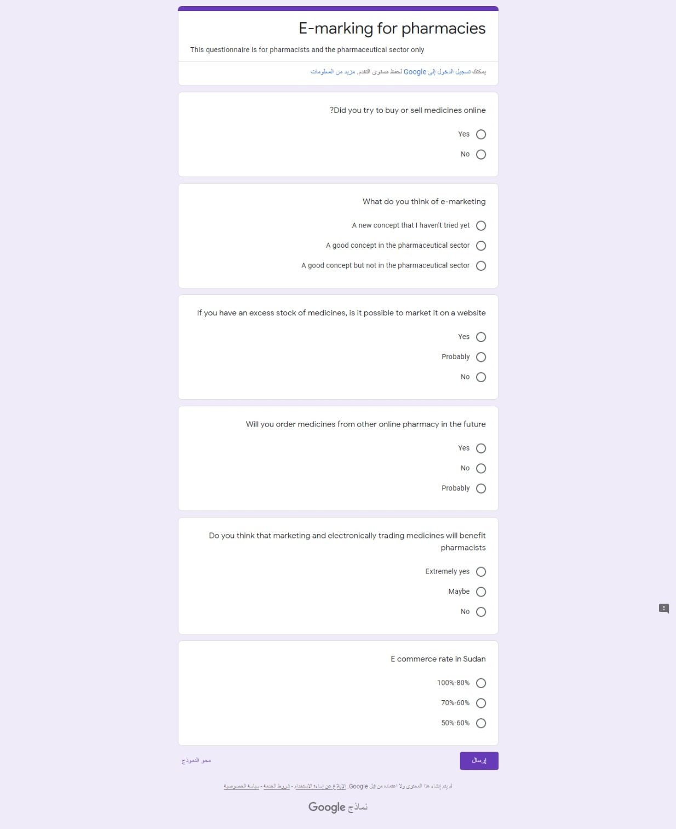

**4.5 system design**

In this section shows the design for the system that will be implemented

4.5.1 use case diagram

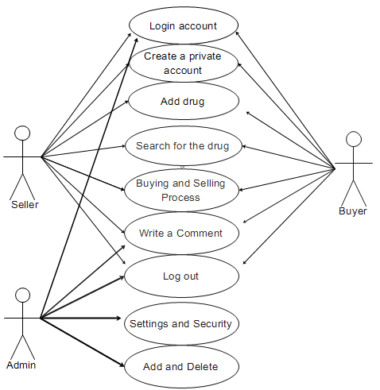

**4.6 Implementation**

In this section we will shows how the web site exactly impalement

4.6.1 Flow chart

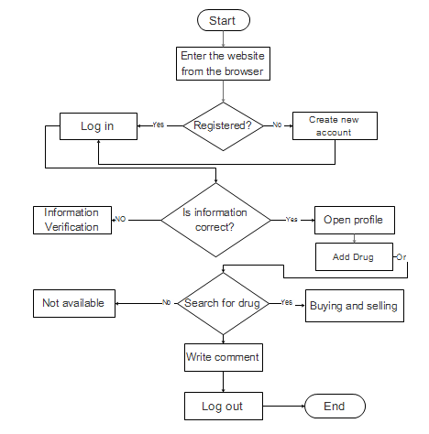

This diagram shows the sequence of the project

***Scenario***

When a user visits the "project name" site, the first page he sees is the home page of the site.  
You can search for the medicine on the home page So if you find the medicines you transfer to the pharmacy profile to contact him directly, but If the pharmacist cannot find the drug, a page appears (No results found), and the buyer's purchase is completed. In "contact us", the user can write a comment or message regarding the site, but if the user wants to register, he goes to the "join us" page, which has two options: If you already have an account, log in; then you don't, create a new account. Once he creates the new account and enters all his information, his personal page will appear. This will allow him to add a profile picture and list the medicines and products he wants to sell.